**Write queries for the following**

1. Create the Customer table with the following columns.

CustomerId Number(5)

Cust_Name varchar2(20)

Address1 Varchar2(30)

Address2 Varchar2(30)

Create table Customer

(

CustomerId int,

Cust_Name varchar(20),

Address1 varchar(20),

Address2 varchar(20)

);

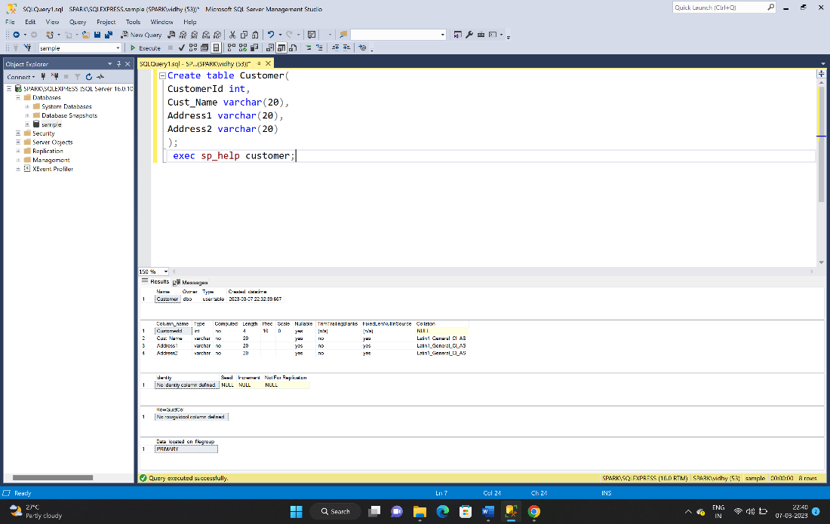

1. Modify the Customer table Cust_Name column of datatype with Varchar2(30), rename the column to CustomerName and it should not accept Nulls.

alter table customer

alter column Cust_Name varchar(30) not null;

exec sp_rename 'dbo.customer.Cust_Name', 'CustomerName', 'COLUMN';

exec sp_help customer;

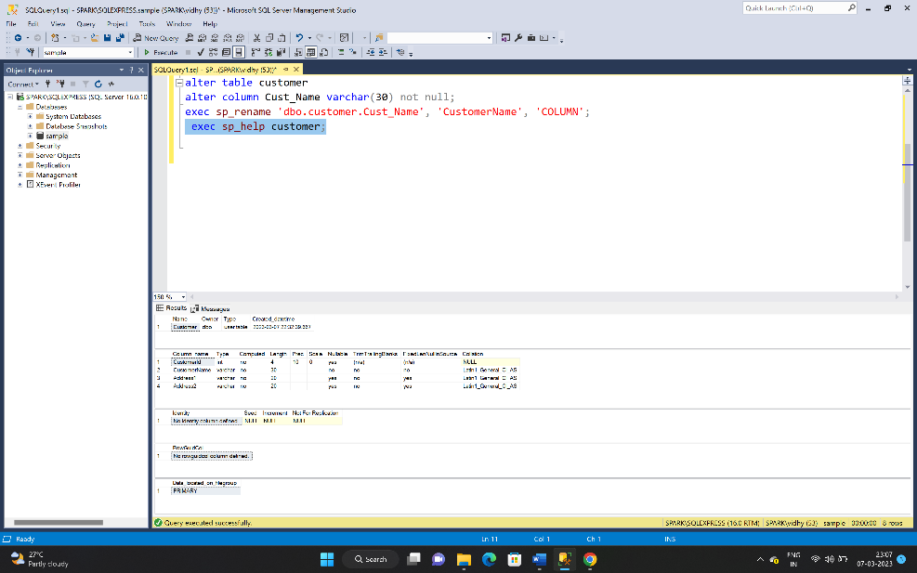

1. Add the following Columns to the Customer table.

Gender Varchar2(1)

Age Number(3)

PhoneNo Number(10)

alter table customer

add Gender Varchar(1),

Age int,

PhoneNo int;

exec sp_help customer;

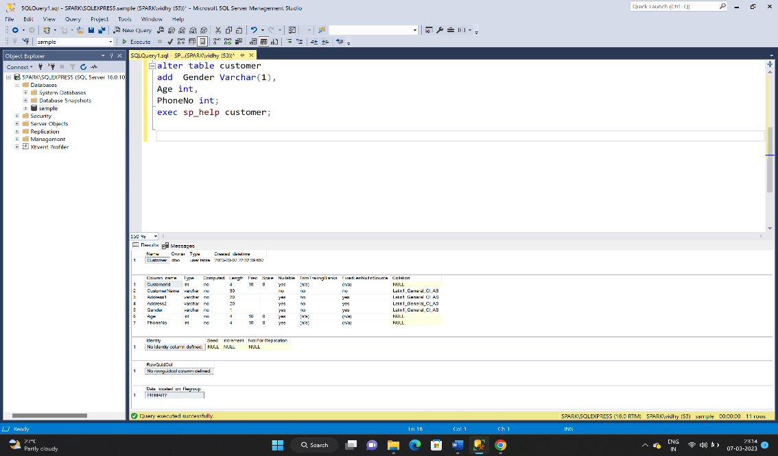

1. Add the below records to the Customer table:

(1000, ‘Allen’, ‘#115 Chicago’, ‘#115 Chicago’, ‘M’, ‘25, 7878776’)

1000, Allen, #115 Chicago, #115 Chicago, M, 25, 7878776

1001, George, #116 France, #116 France, M, 25, 434524

1002, Becker, #114 New York, #114 New York, M, 45, 431525

insert into customer values(1000, 'Allen', '#115 Chicago', '#115 Chicago','M', 25, 7878776),

(1001, 'George', '#116 France', '#116 France', 'M', 25, 434524),

(1002, 'Becker', '#114 New York', '#114 New York', 'M', 45, 431525);

select*from customer;

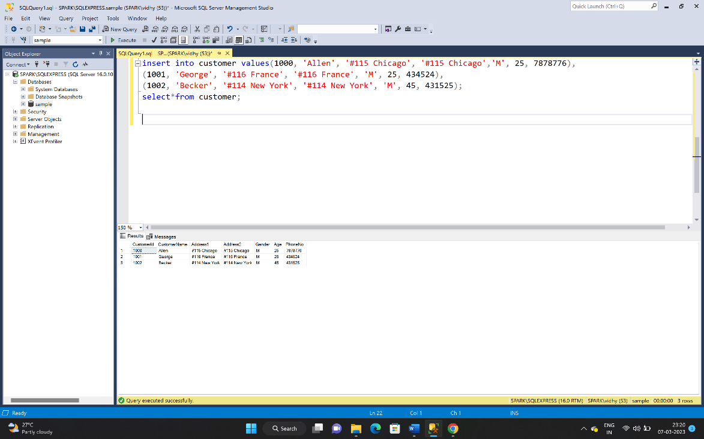

1. Add the Primary key constraint for Customerld with the name Custld_Prim.

alter table customer alter column CustomerId int not null;

Alter table Customer add constraint pk_CustId_prim primary key(CustomerId);

select * from Customer;

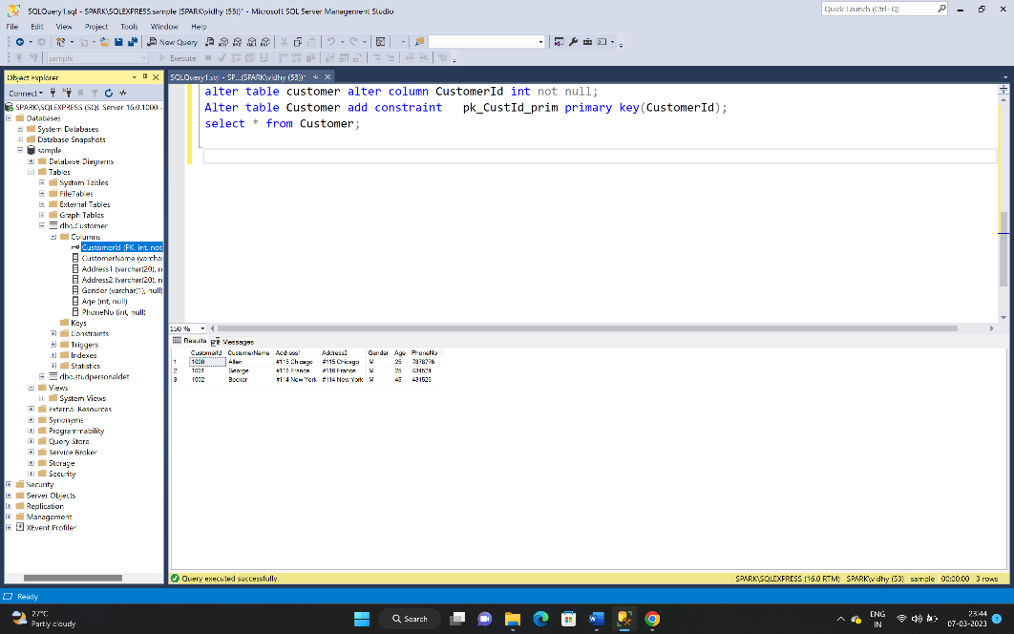

1. a) Disable the constraint on CustomerId, and insert the following data:

1002, Becker, #114 New York, #114 New york , M, 45, 431525

1003, Nanapatekar, #115 India, #115 India , M, 45, 431525

b) Drop the constraint Custld_Prim on CustomerId and insert the following Data.

alter table customer drop constraint pk_CustId_prim ;

insert into customer values(1002, 'Becker', '#114 New York', '#114 New york' , 'M', 45, 431525),

(1003, 'Nanapatekar', '#115 India', '#115 India' , 'M', 45, 431525);

select * from Customer;

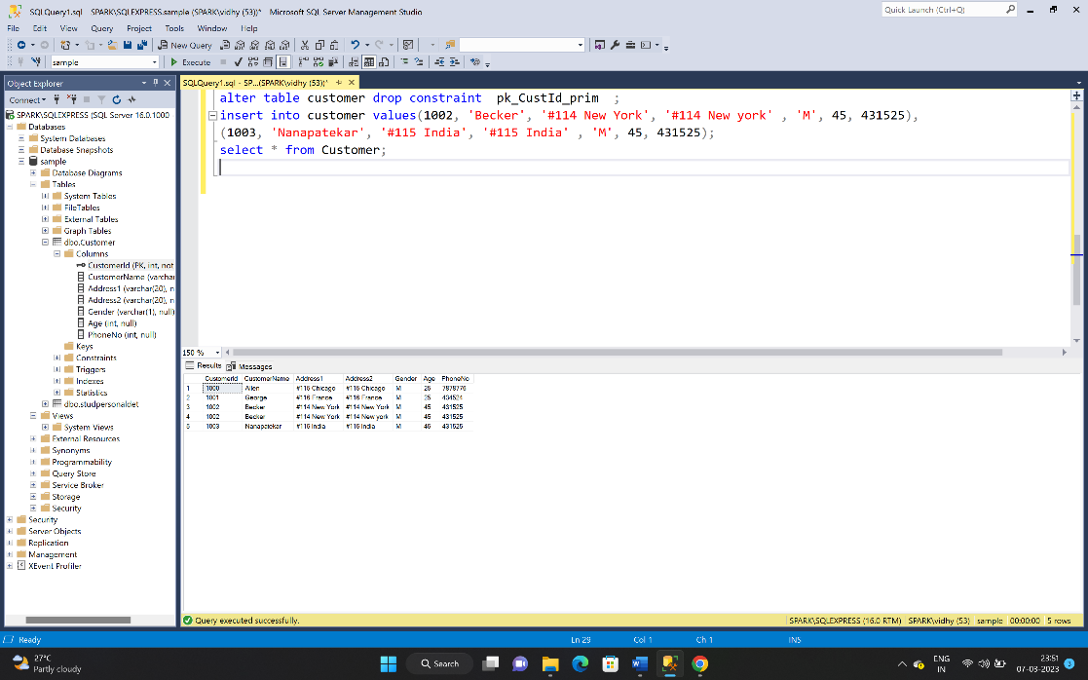

1. Alter Customer table, drop constraint Custid_Prim.

1002, Becker, #114 New York, #114 New york , M, 45, 431525, 15000.50

1003, Nanapatekar, #115 India, #115 India , M, 45, 431525, 20000.50

alter table customer add amount float;

update customer set amount=15000.50 where CustomerId=1002;

update customer set amount=20000.50 where CustomerId=1003;

select * from Customer;

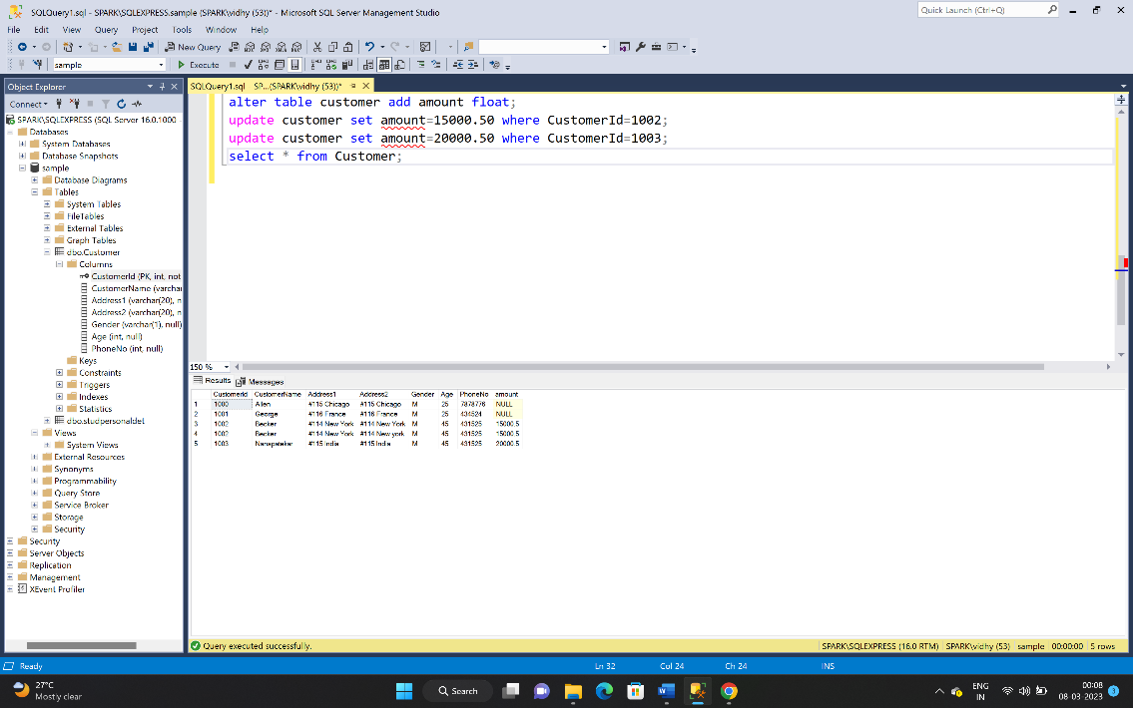

1. Create Employee table with same structure as EMP table.

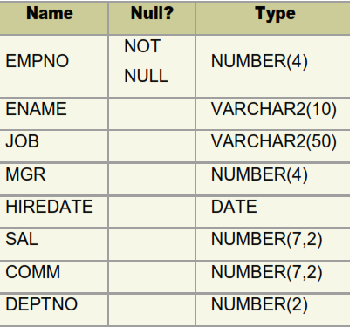

create table Employee

(

EMPNO int not null,

ENAME varchar(10),

JOB varchar(50),

MGR int,

HIREDATE date,

SAL int,

COMM int,

DEPTNo int

);

exec sp_help Employee;

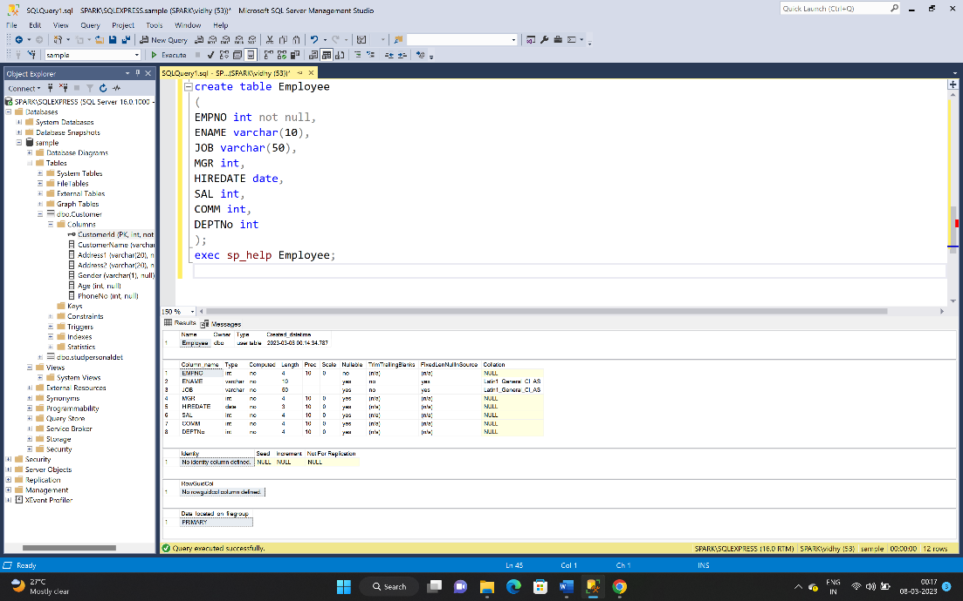

1. Insert the following data in the above table

insert into Employee (EMPNO,ENAME,SAL,DEPTNo)

values(7369,'SMITH',800,20),(7499,'ALLEN',1600,30),

(7521,'WARD',1250,30),(7566,'JONES',2975,20),

(7654,'MARTIN',1250,30),(7698,'BLAKE',2850,30),

(7782,'CLARK',2450,10),(7788,'SCOTT',3000,20),

(7839,'KING',5000,10),(7844,'TURNER',1500,30),

(7876,'ADAMS',1100,20),(7900,'JAMES',950,30),

(7902,'FORD',3000,20),(7934,',MILLER',1300,10);

select*from Employee;

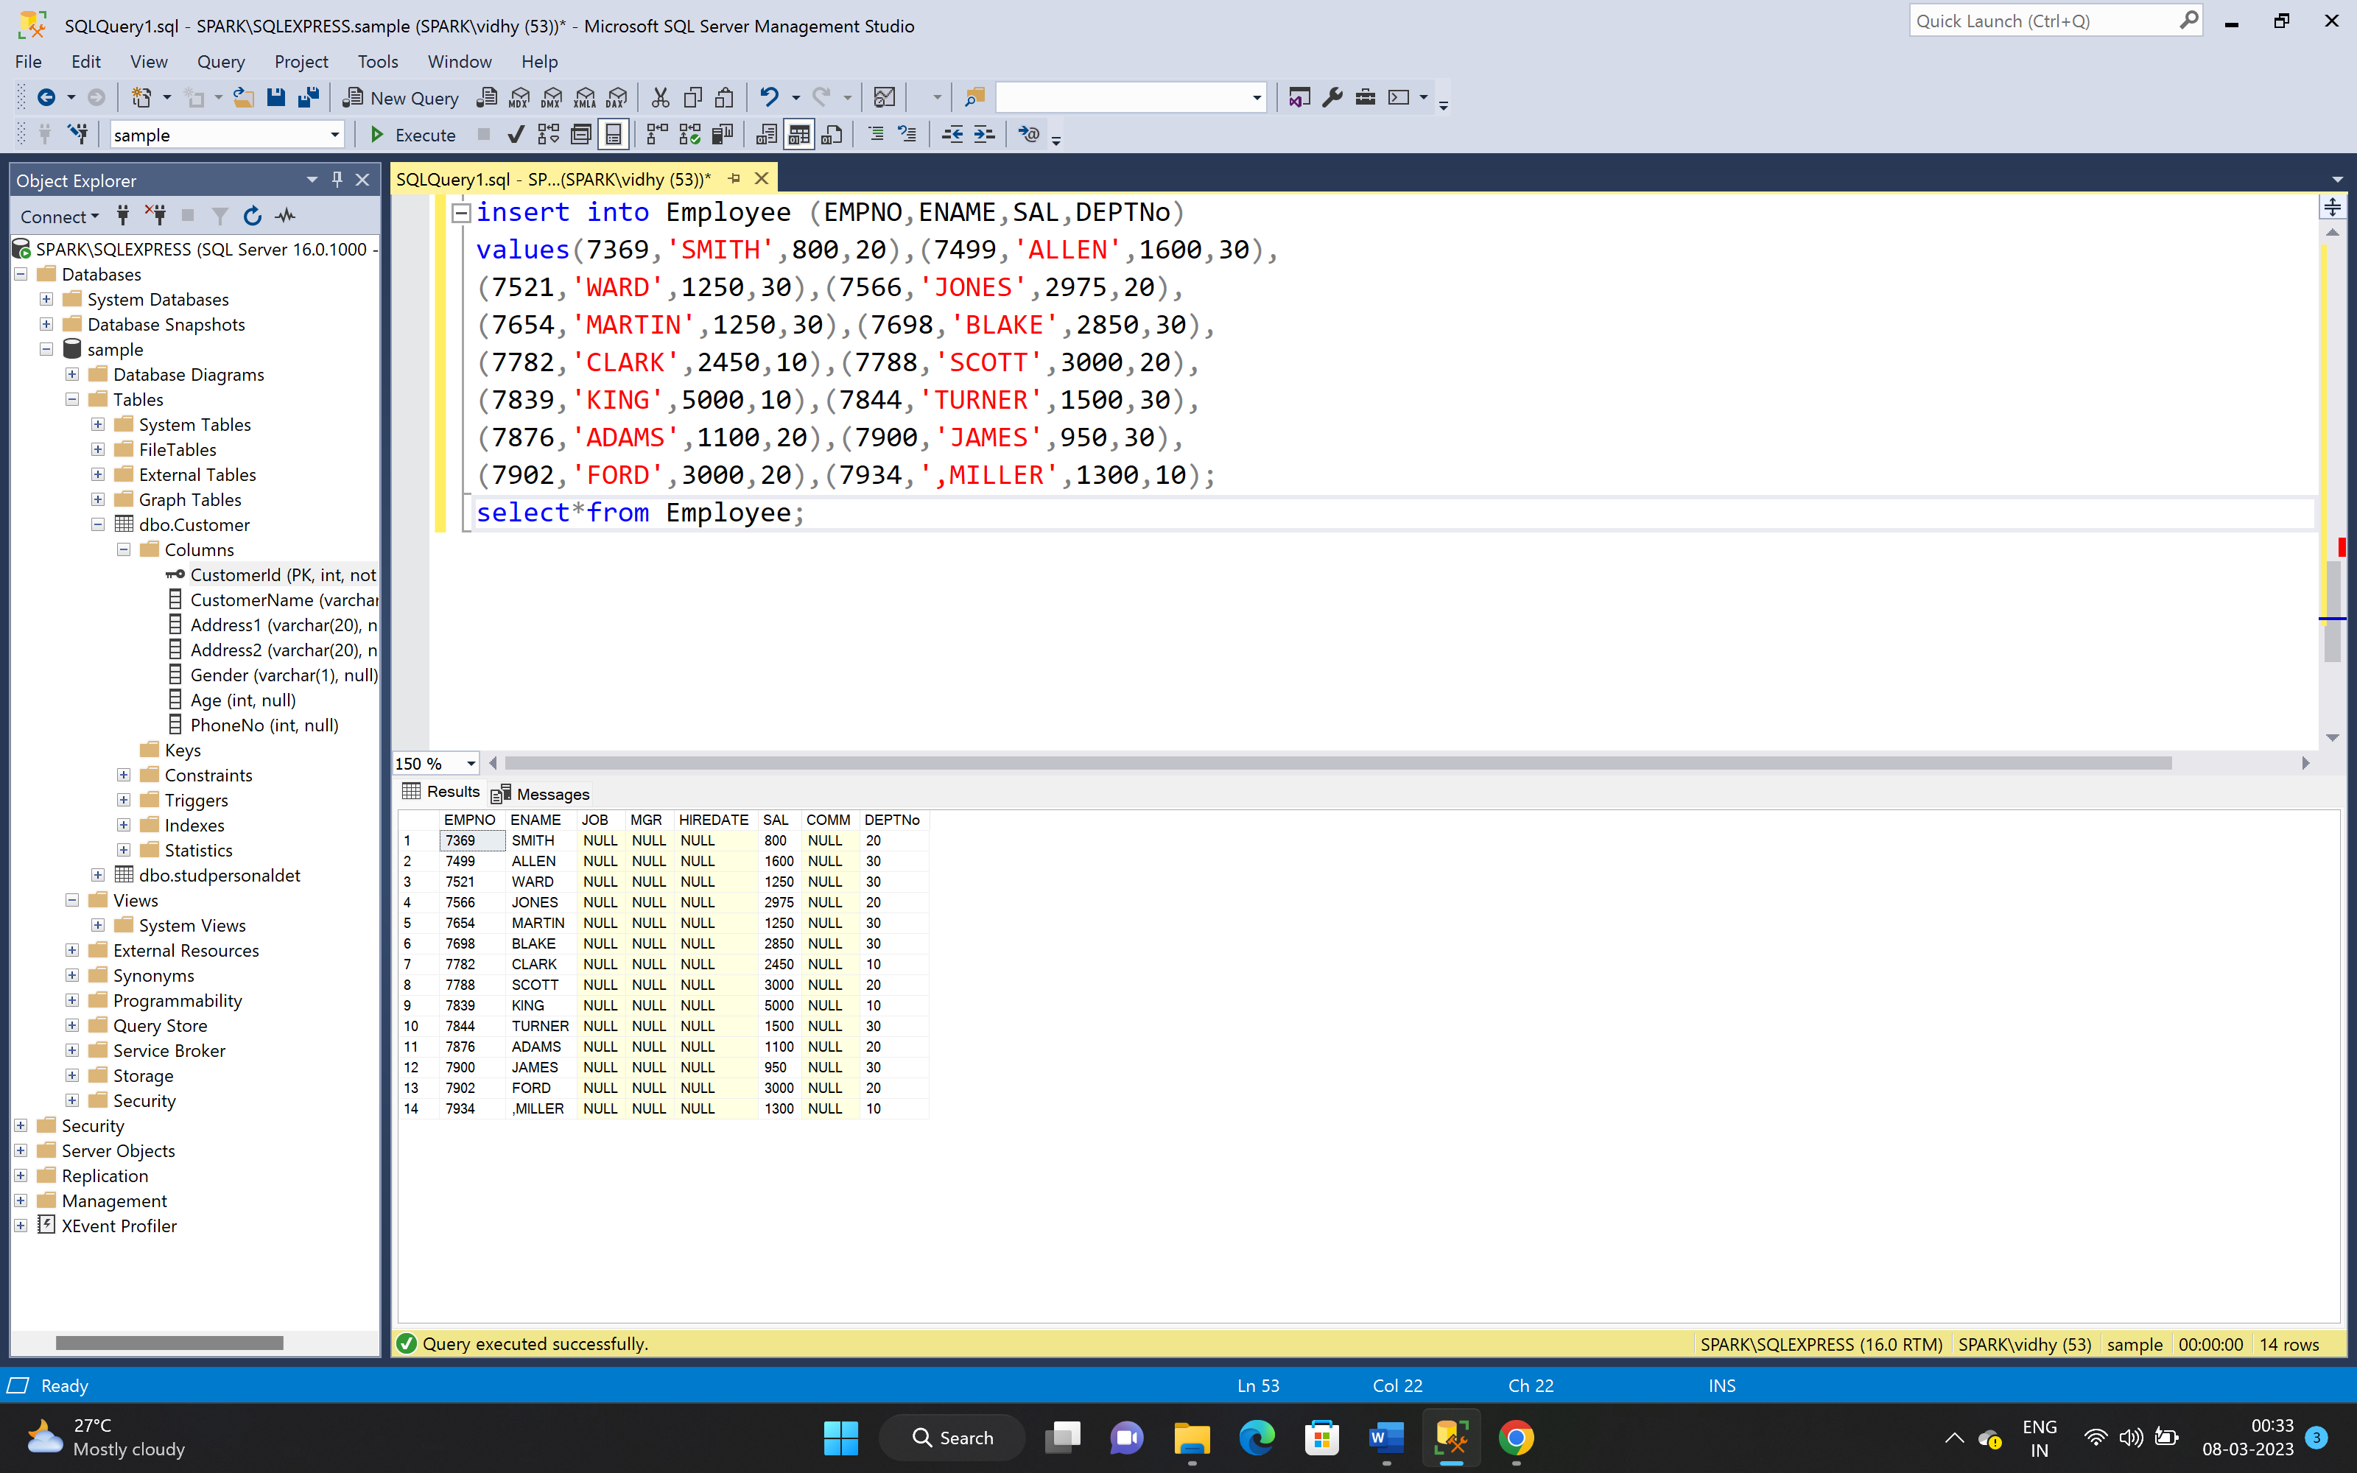

1. Write a query to populate Employee table using EMP table’s empno, ename, sal,, deptno columns.

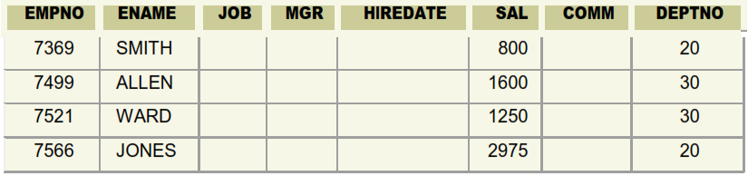

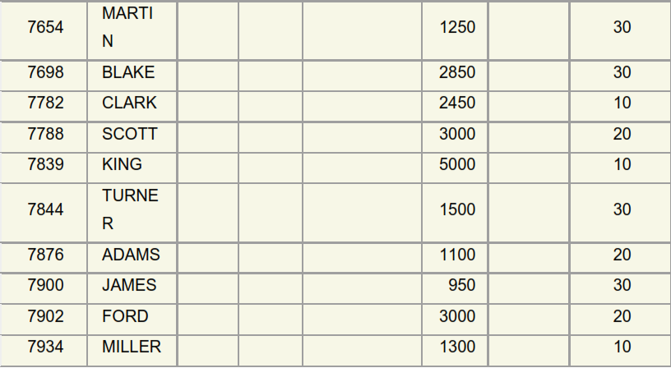

Select * from Employee;

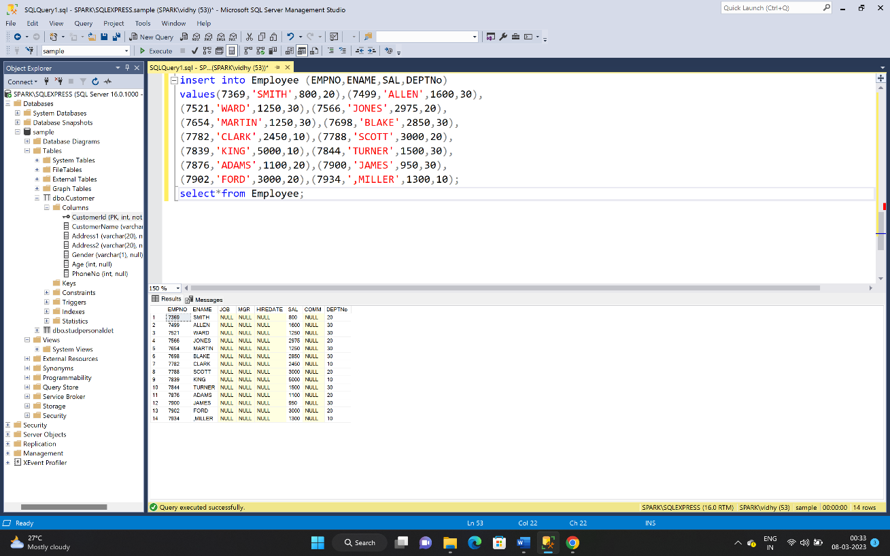

1. a. Write a query to change the job and deptno of employee whose empno is 7698 to the job and deptno of employee having empno 7788.

b. Write a query to change the deptno of employee with empno 7788 to that of employee having empno 7698.

A). update employee set job=(select job from employee where empno=7788),

deptno=(select deptno from employee where empno=7788)

where empno=7698;

select*from Employee;

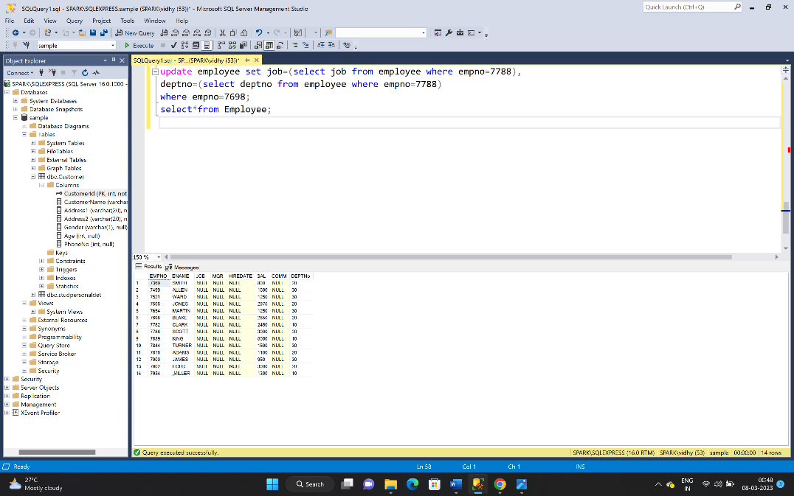

B). update employee set deptno=(select deptno from employee where empno=7698)

where empno=7788;

select * from Employee;

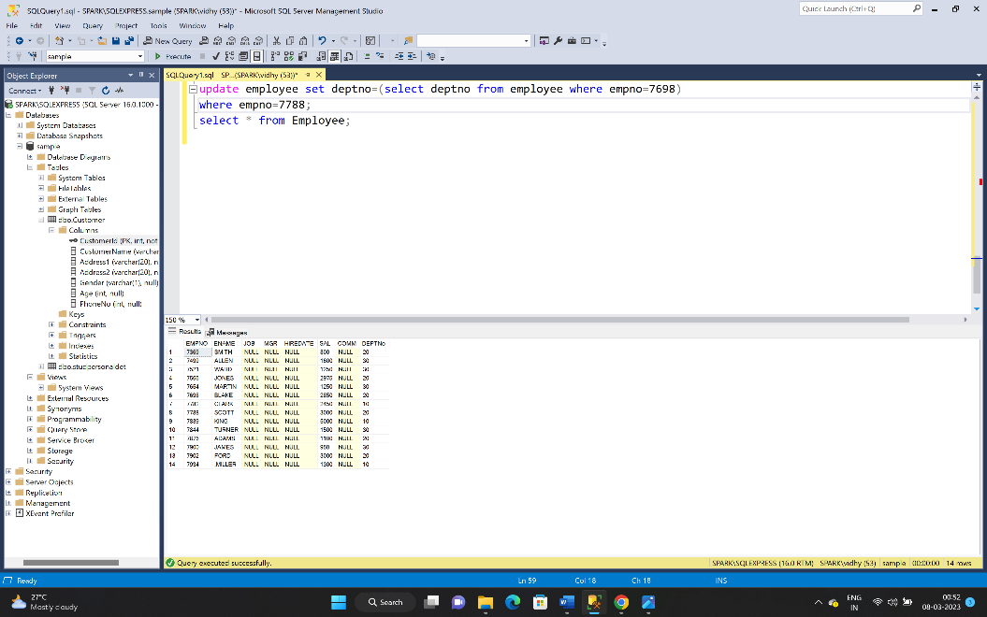

1. Delete the details of department whose department name is ‘SALES’.

alter table Employee add departmentname varchar(10);

update Employee set departmentname= 'sales' where DEPTNo=30;

update Employee set departmentname= 'sales' where DEPTNo=20;

delete from employee where departmentname like '%sales%';

select * from Employee;

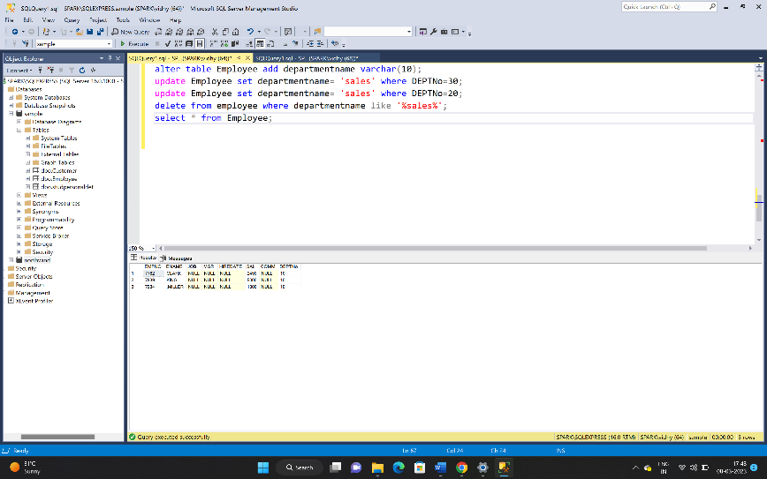

1. Insert the following rows to the Employee table

1000,Allen, Clerk,1001,12-jan-01, 3000, 2,10

1001,George, analyst, null, 08 Sep 92, 5000,0, 10

1002, Becker, Manager, 1000, 4 Nov 92, 2800,4, 20

1003, 'Bill', Clerk, 1002, 4 Nov 92,3000, 0, 20

select * from Employee;

Insert into Employee values(1000,'Allen', 'Clerk',1001,'12-jan-01', 3000, 2,10);

Insert into Employee values(1001,'George', 'analyst', null, '08-Sep-92', 5000,0, 10);

Insert into Employee values(1002, 'Becker', 'Manager', 1000, '4-Nov-92', 2800,4, 20);

Insert into Employee values(1003, 'Bill', 'Clerk', 1002, '4-Nov-92',3000, 0, 20);

select * from Employee;

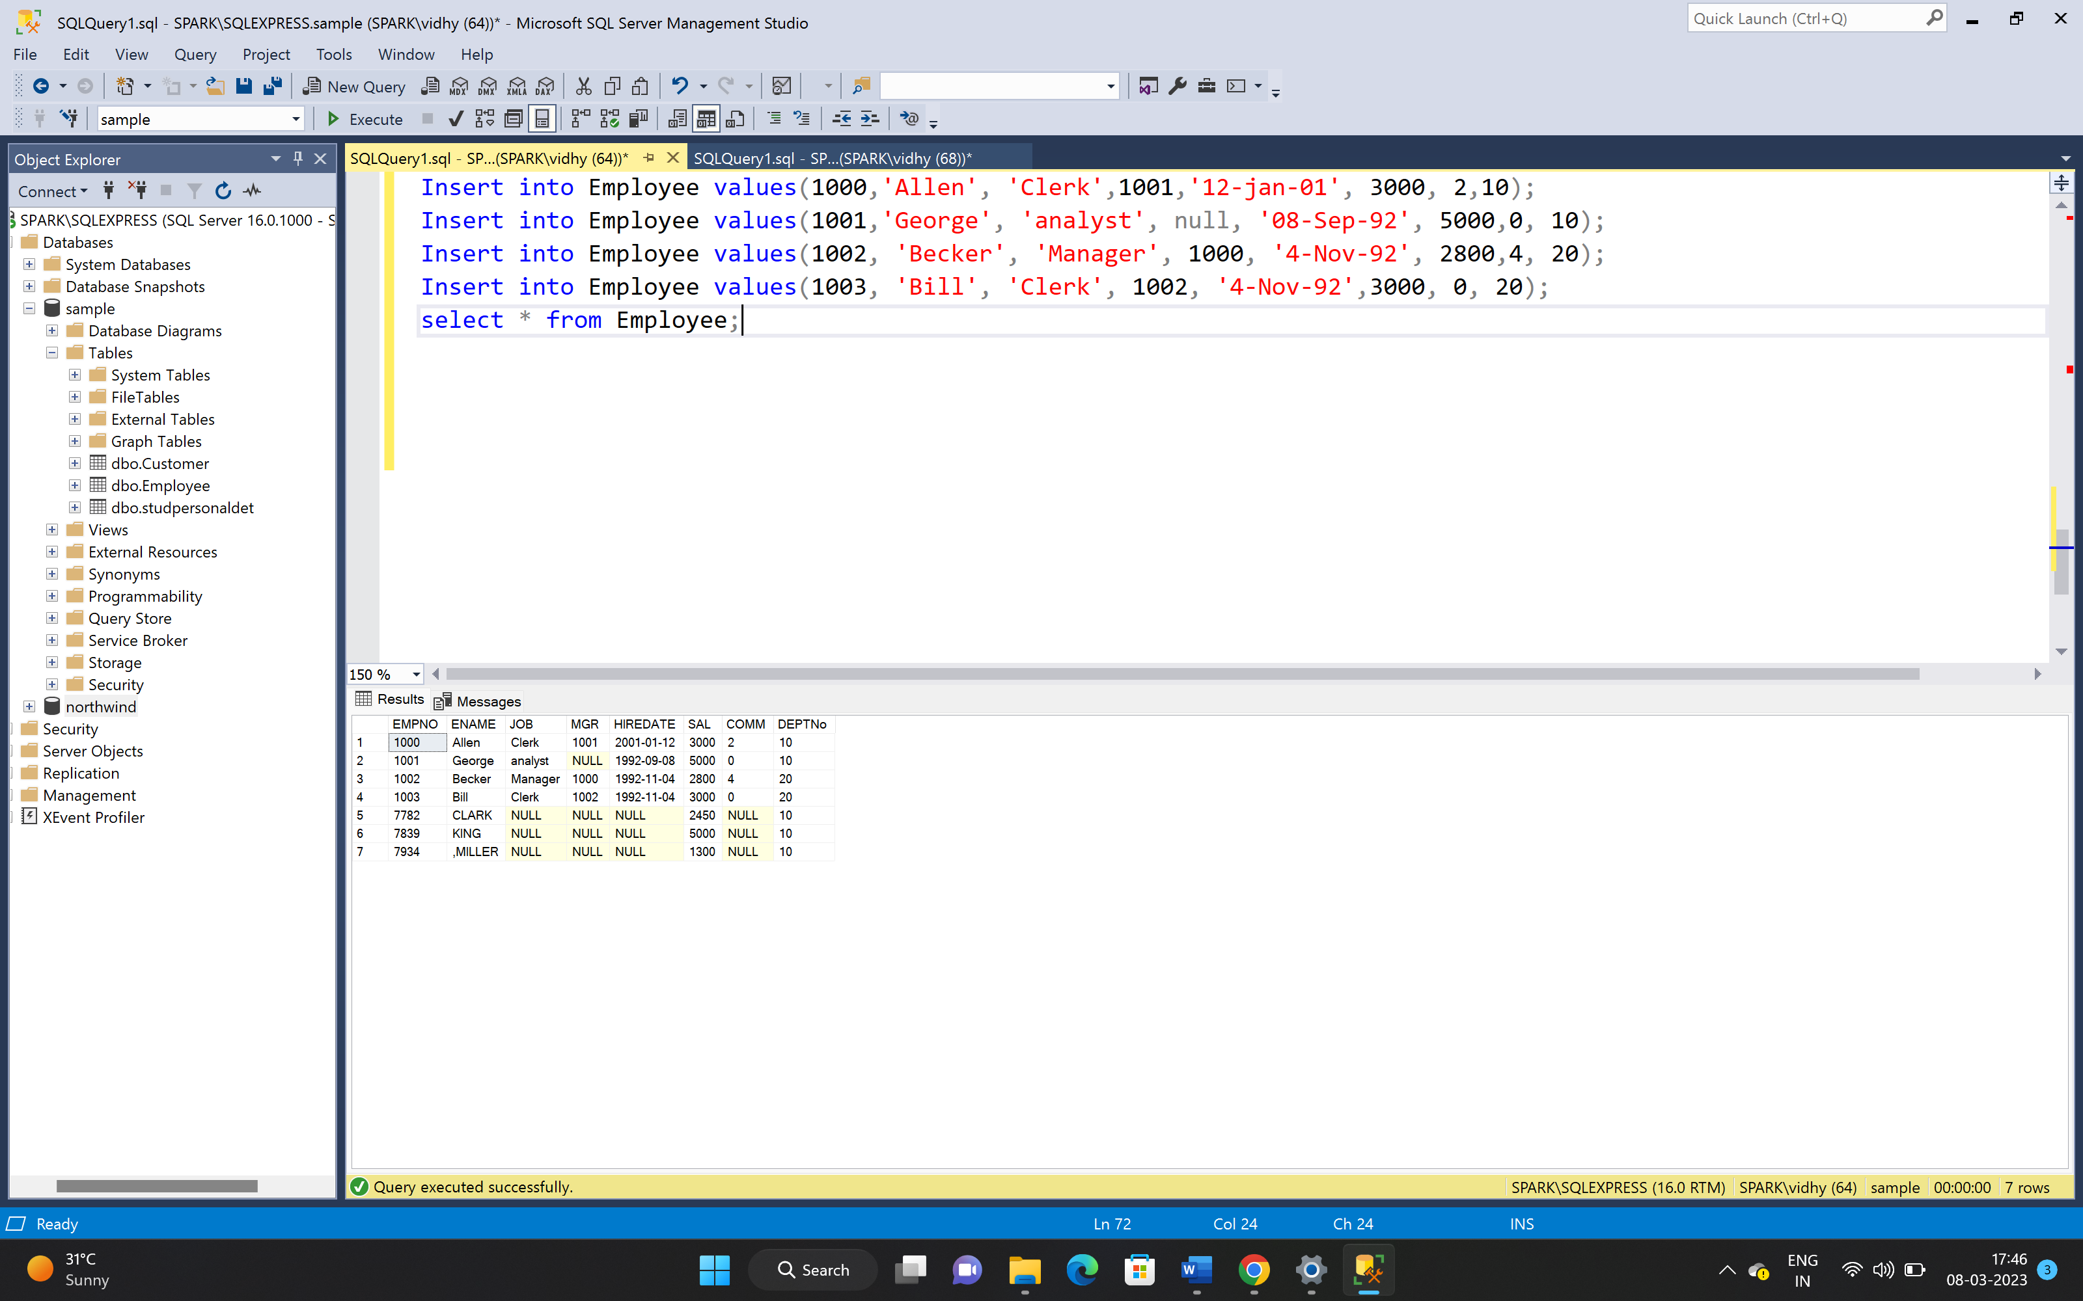

1. Create a Project Table with below structure

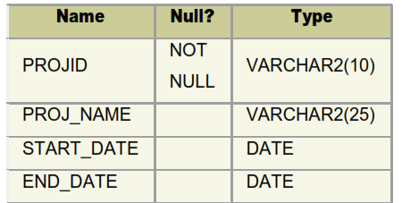

Create table Project (

PROJID varchar(10) not null,

PROJ_NAME varchar(25),

START_DATE date,

END_DATE date

);

exec sp_help Project;

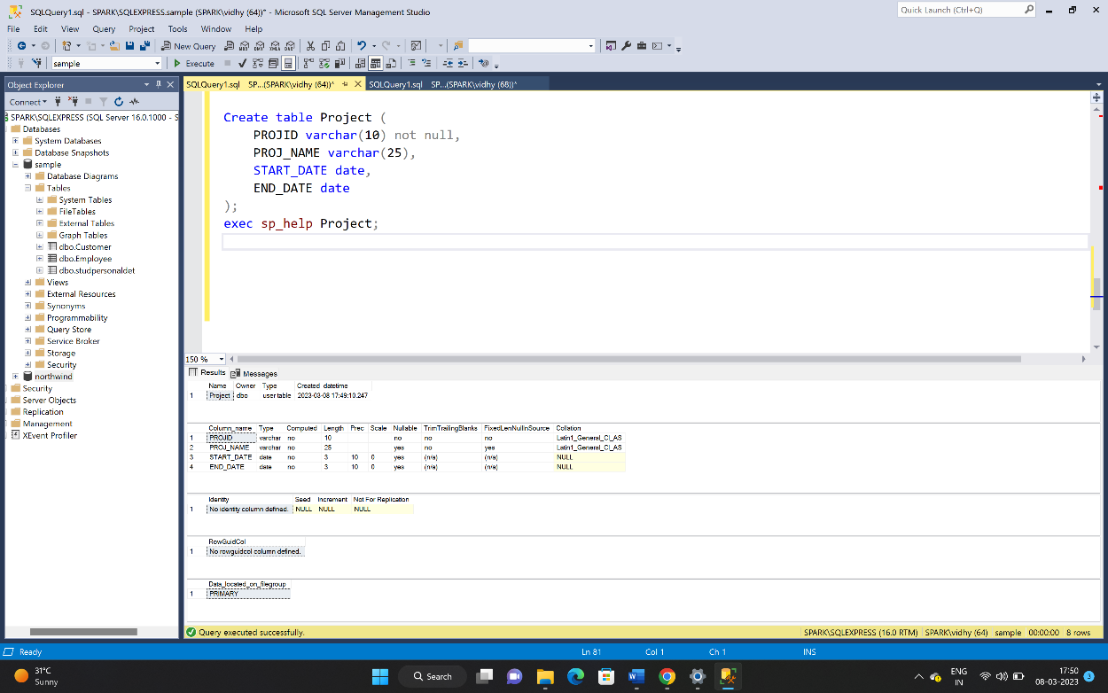

1. Insert Records into Project Table as deemed necessary and relevant

Insert into project(PROJID, PROJ_NAME, START_DATE, END_DATE)

Values(123, 'abc', '2022/01/23', '2022/02/23');

Insert into project(PROJID, PROJ_NAME, START_DATE, END_DATE)

Values(124, 'pqr', '2022/03/23', '2022/04/23');

Insert into project(PROJID, PROJ_NAME, START_DATE, END_DATE)

Values(124, 'xyz', '2022/06/23', '2022/07/23');

select * from Project;

